GP PATIENT SURVEY RESULTS

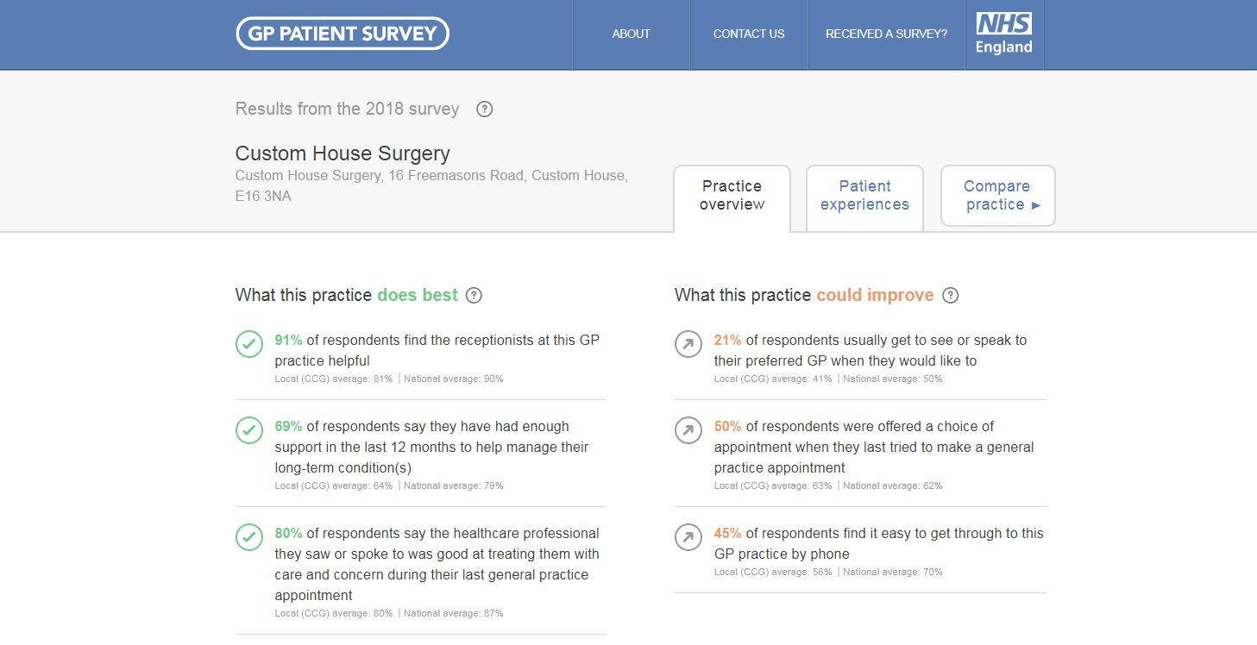

The GP Patient Survey is an independent survey run by Ipsos MORI on behalf of NHS England. The survey is sent out to over a million people across the UK. The results show how people feel about their GP practice.

August 2018